**ML System Design Youtube Video Search**

<https://www.youtube.com/watch?v=NE9JIIaNhQk&list=PL_b_MRp1BnEj4UuHv1jAGeO1a0VTRXsAk&index=8>

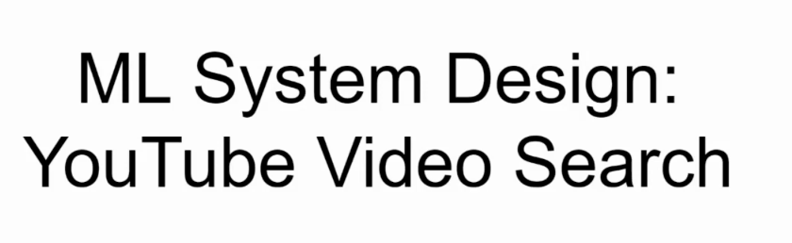

Clarifying Requirement

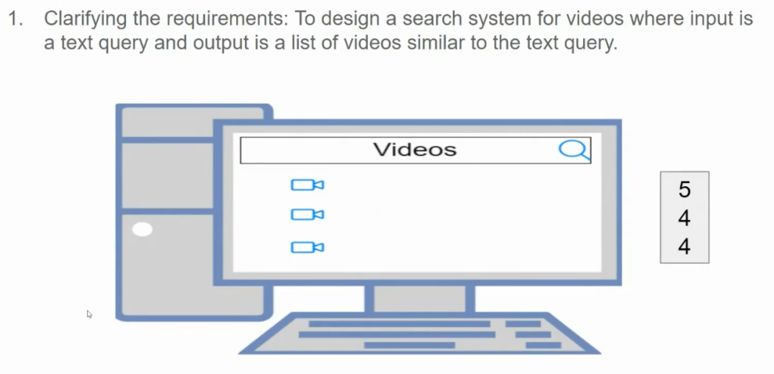

Framing as ML task

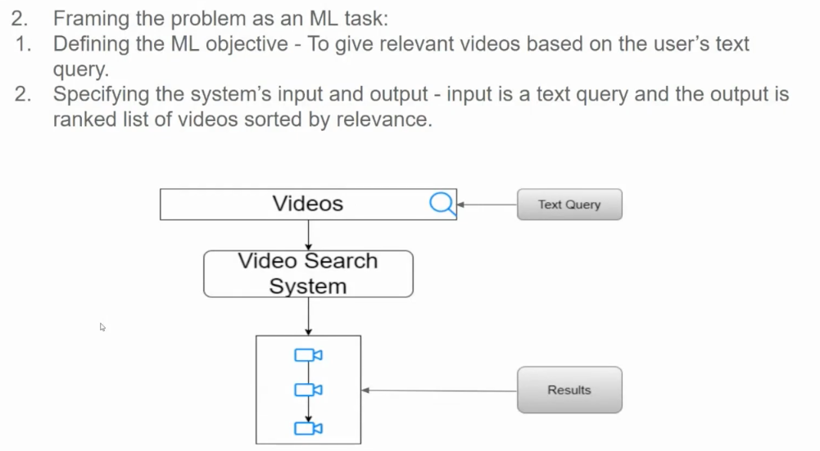

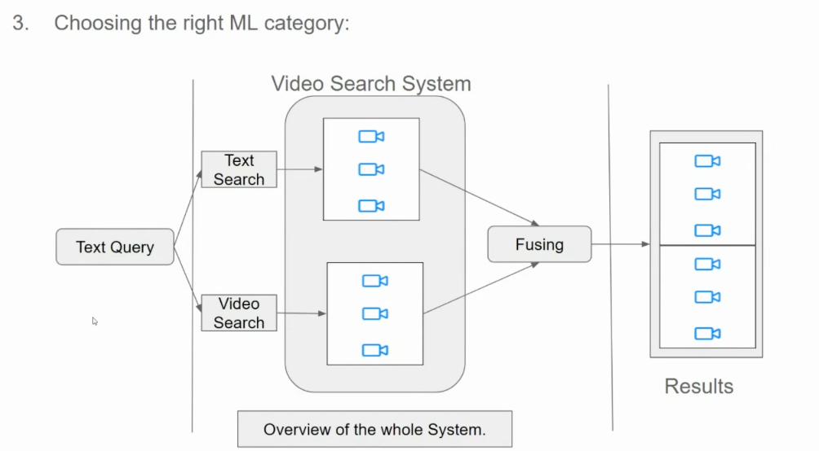

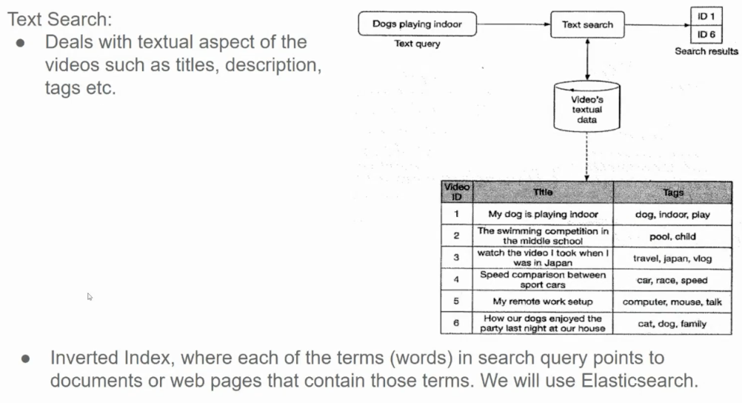

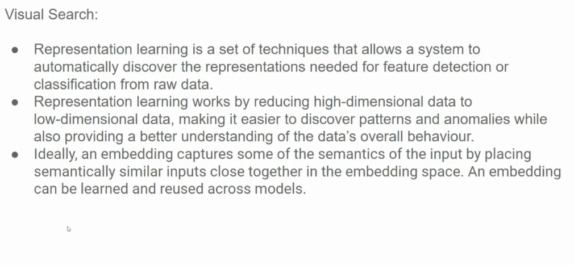

**Representation learning** is a set of techniques that enable a machine learning model to automatically learn meaningful representations of data. Instead of relying on handcrafted features, the model learns these representations directly from the raw data.

**Key Points:**

* **Dimensionality Reduction:** Representation learning often involves reducing high-dimensional data into lower-dimensional spaces. This makes it easier to process and analyze the data.
* **Feature Extraction:** The learned representations capture the underlying structure and patterns in the data. These representations can be thought of as features that are automatically extracted from the raw data.
* **Semantic Similarity:** Ideally, the learned representations should capture the semantic similarity between different data points. For example, images of cats should be closer together in the embedding space than images of dogs.

**Why is Representation Learning Important?**

* **Improved Performance:** By learning meaningful representations, models can achieve better performance on tasks like classification, regression, and clustering.
* **Reduced Feature Engineering:** It eliminates the need for manual feature engineering, saving time and effort.
* **Transfer Learning:** Learned representations can be transferred to other tasks, leading to faster training and improved performance.

**Common Techniques for Representation Learning:**

* **Autoencoders:** Neural networks that learn to reconstruct input data.
* **Principal Component Analysis (PCA):** A linear dimensionality reduction technique.
* **t-SNE (t-Distributed Stochastic Neighbor Embedding):** A non-linear dimensionality reduction technique for visualizing high-dimensional data.
* **Word Embeddings:** Used to represent words as vectors in a semantic space.

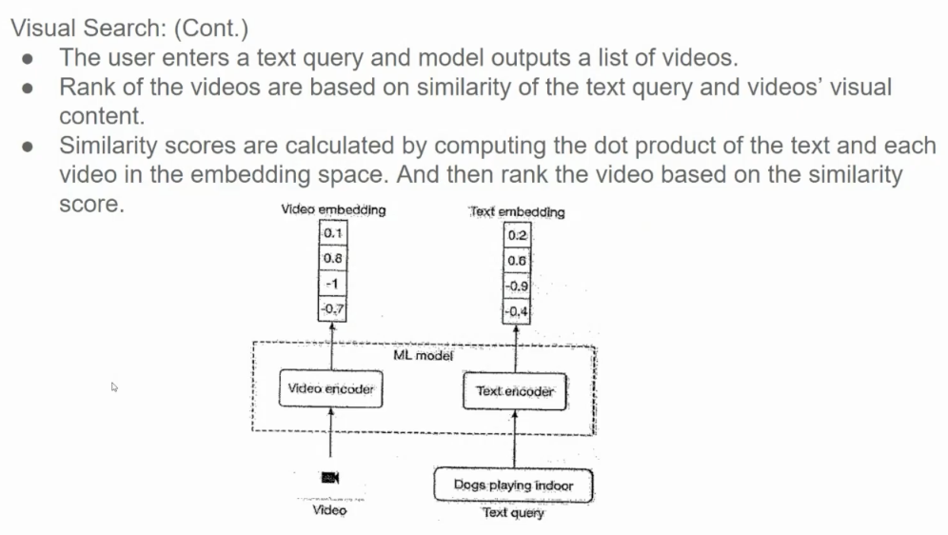

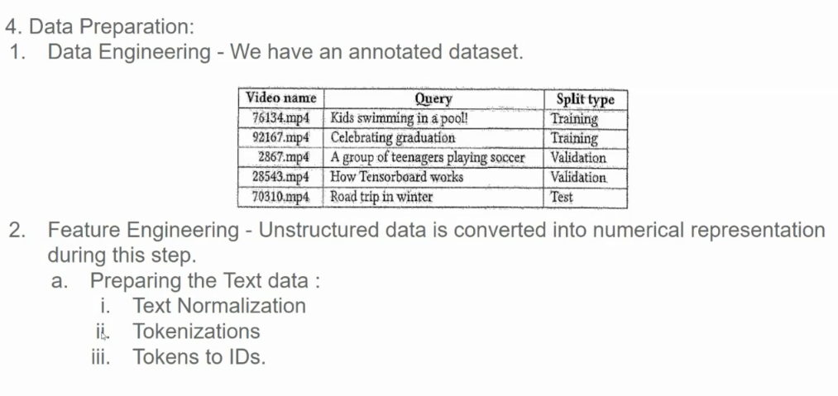

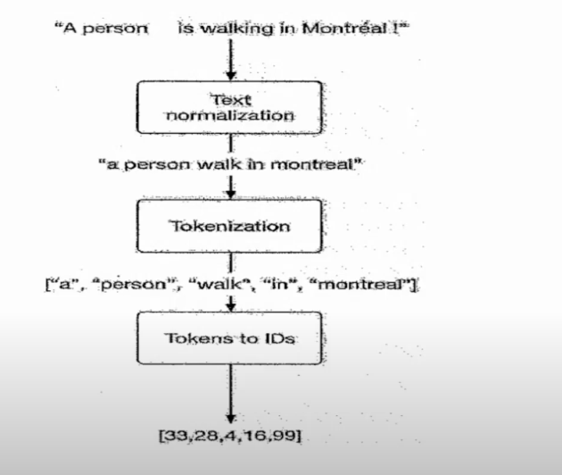

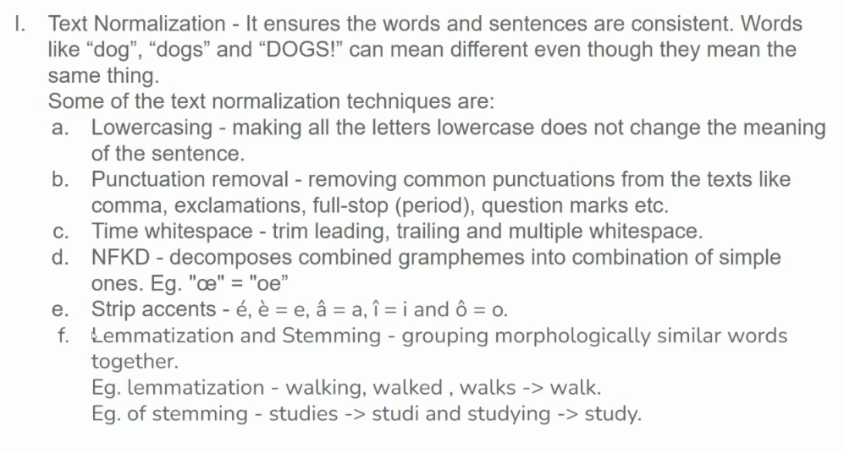

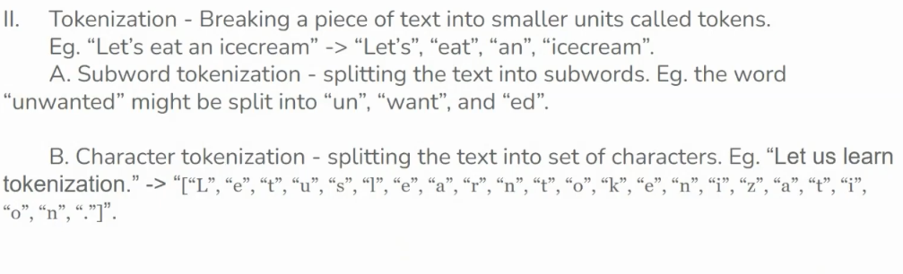

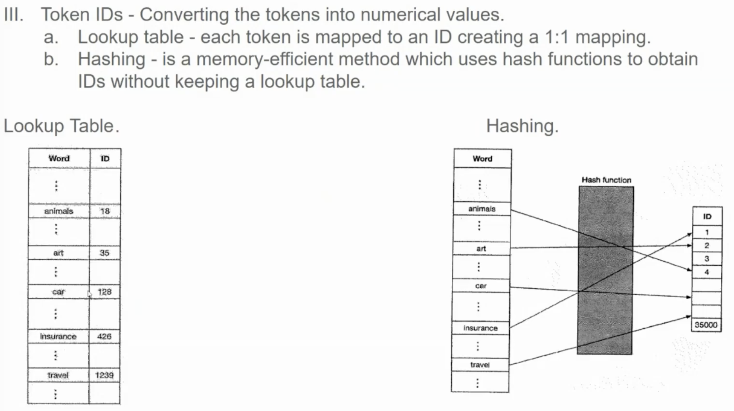

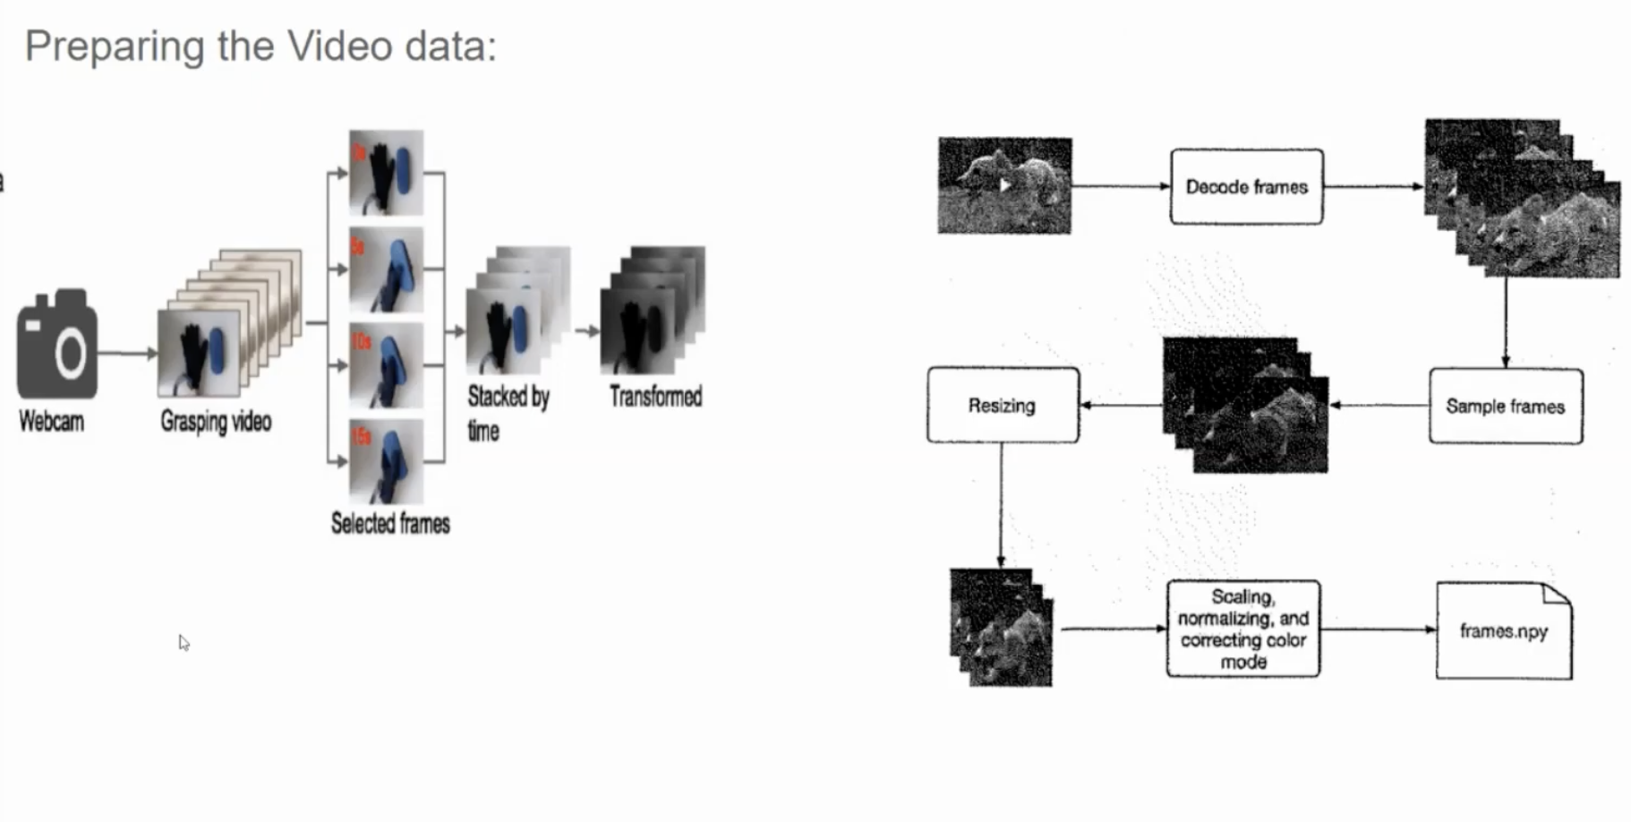

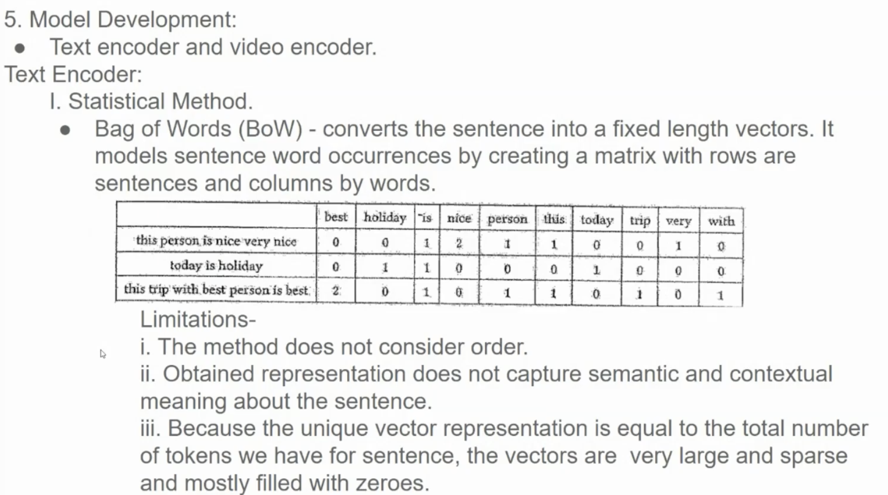

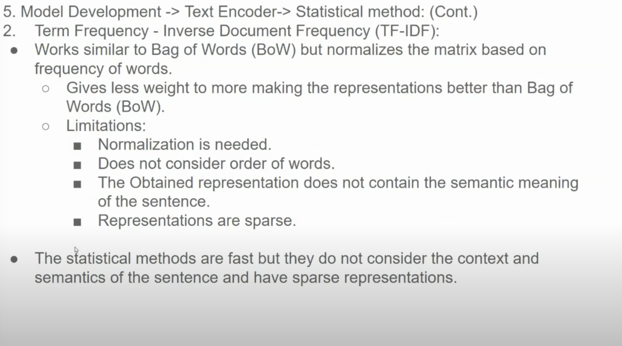

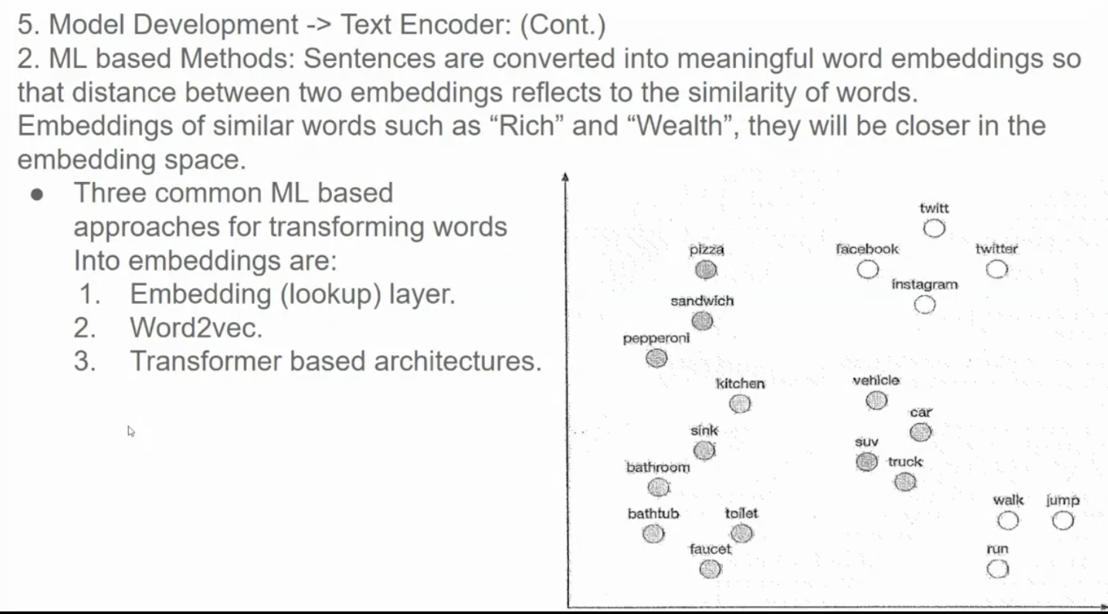

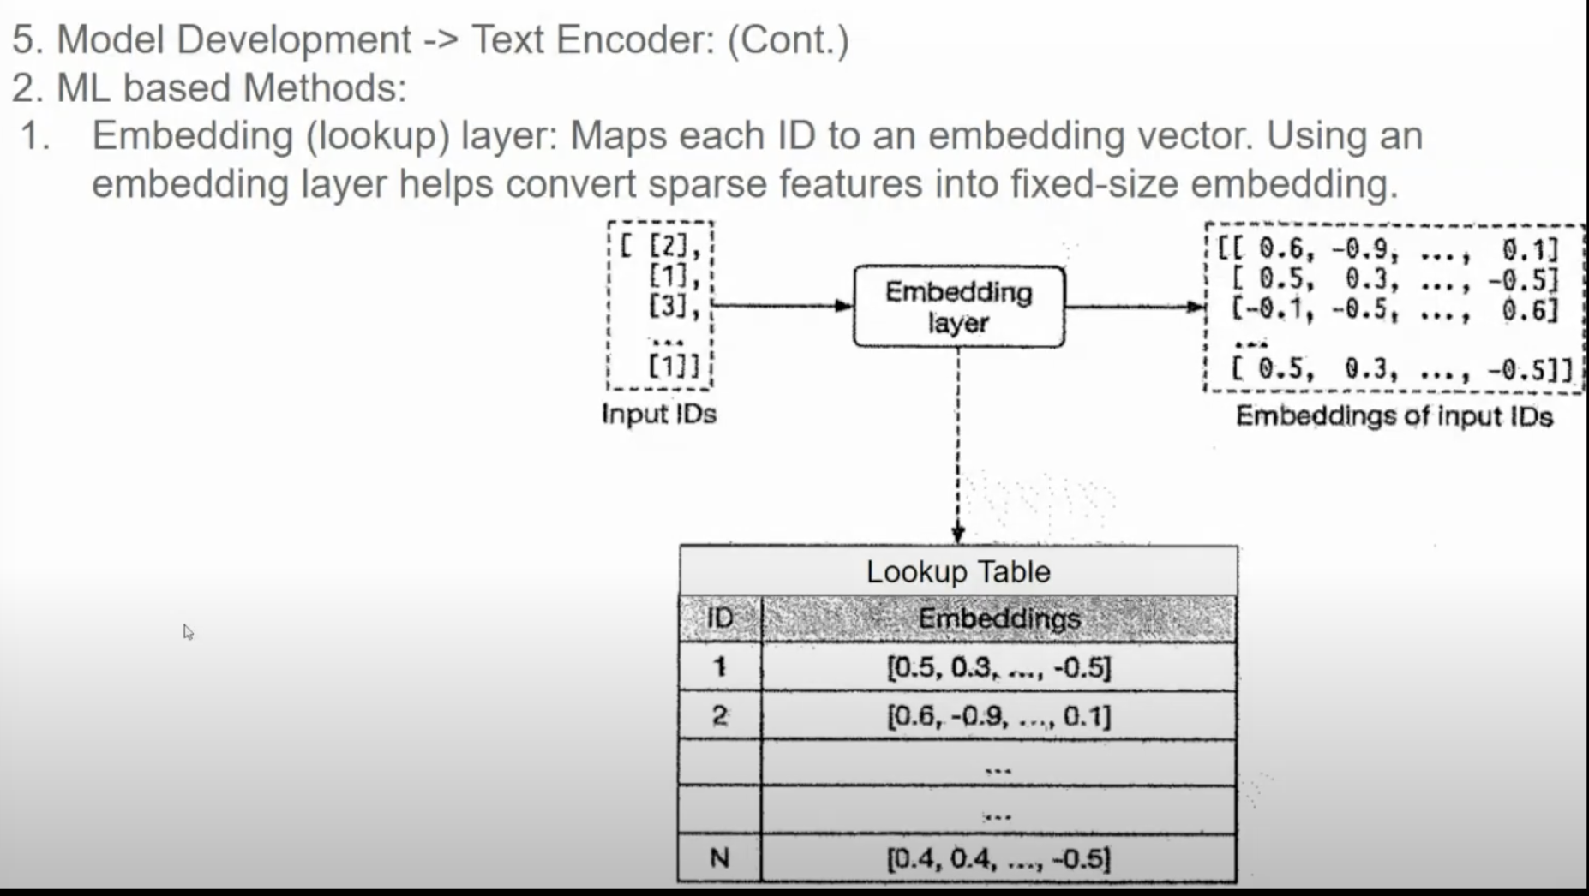

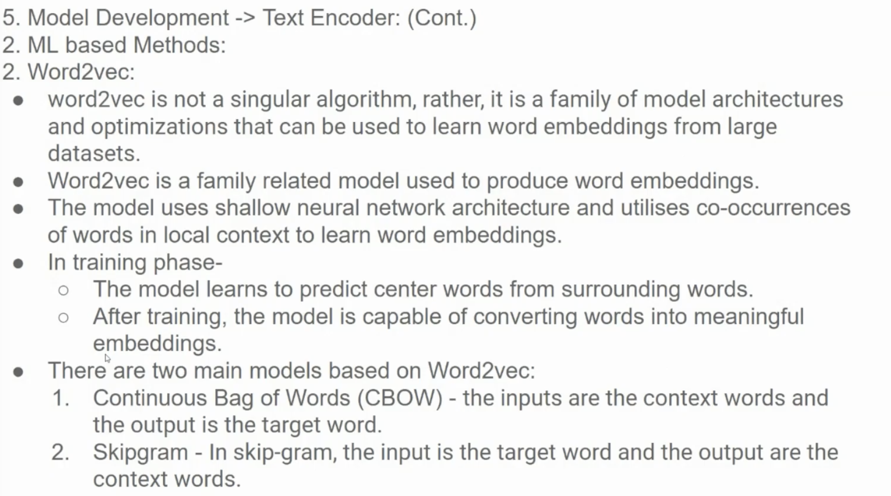

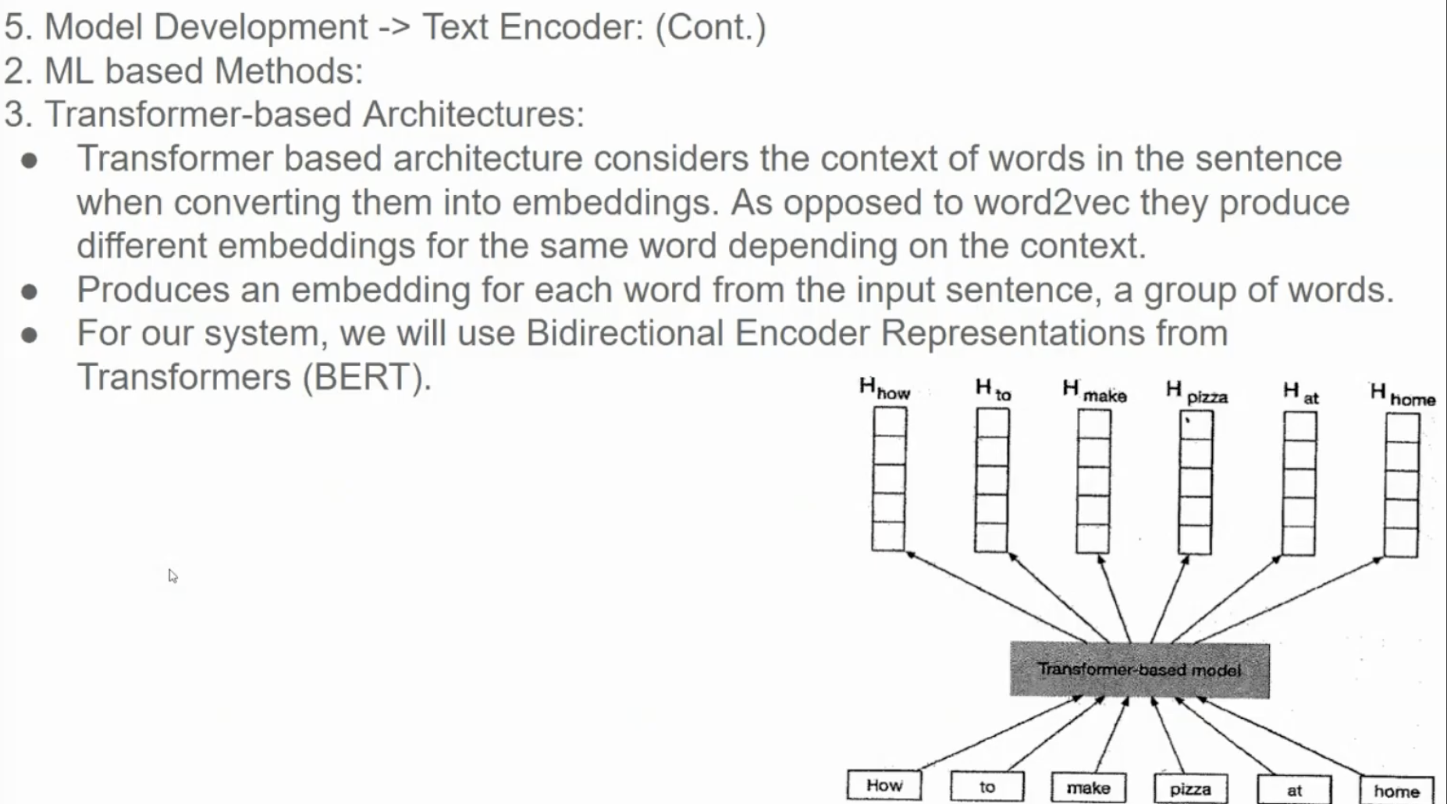

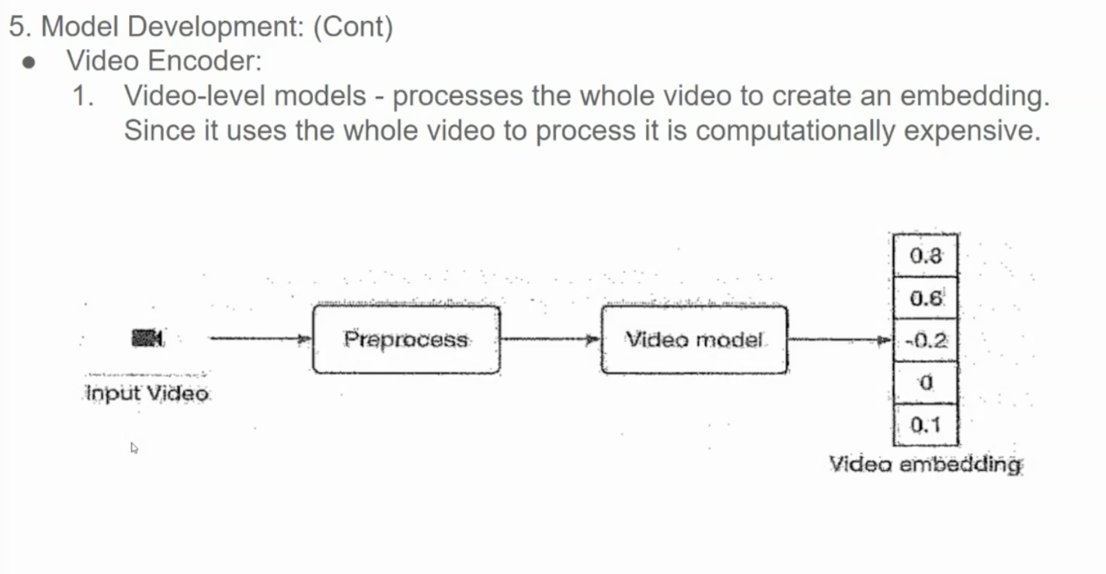

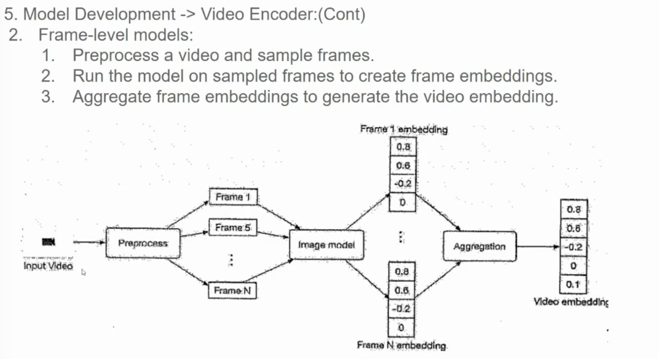

**1. Preprocessing:**

* **Video Input:** The input is a video clip.
* **Frame Sampling:** Key frames are extracted from the video. These frames can be sampled uniformly or based on motion or scene changes.

**2. Frame-Level Model:**

* **Image Model:** Each sampled frame is processed by an image model (e.g., a Convolutional Neural Network) to extract visual features.
* **Frame Embedding:** The image model generates a dense vector representation (embedding) for each frame. This embedding captures the semantic and visual information of the frame.

**3. Aggregation:**

* **Frame Embeddings:** The embeddings of all the sampled frames are combined to form a video-level representation.
* **Aggregation Techniques:** Various techniques can be used to aggregate frame embeddings, such as:
  + **Average Pooling:** Calculating the average of all frame embeddings.
  + **Max Pooling:** Selecting the maximum value from each dimension of all frame embeddings.
  + **Attention-Based Pooling:** Weighting frame embeddings based on their importance to the overall video content.

**Output:**

* **Video Embedding:** The final video embedding is a dense vector representation that captures the overall semantic and visual content of the video.

**Why Frame-Level Models?**

* **Fine-Grained Information:** Frame-level models can capture detailed information about the video content, such as object motion, scene changes, and temporal relationships between frames.
* **Flexibility:** They can be adapted to various video analysis tasks, including action recognition, video classification, and video retrieval.
* **Transfer Learning:** Pre-trained image models can be used as a starting point, saving time and computational resources.

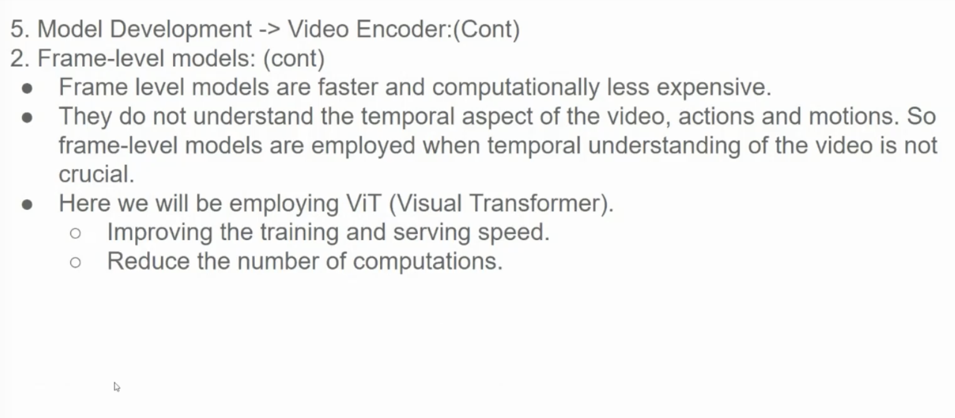

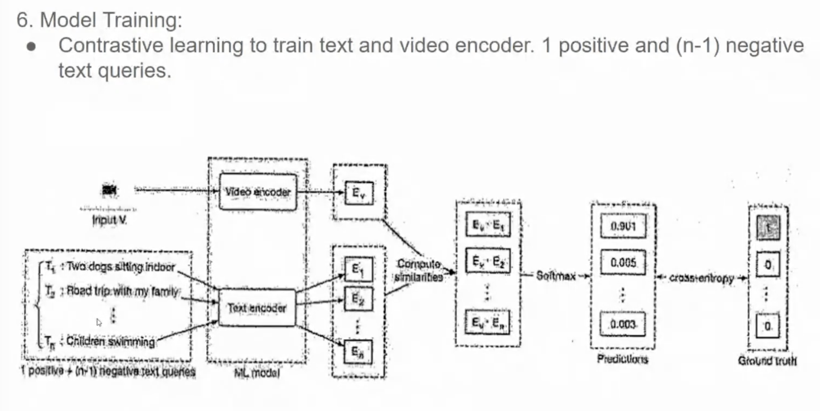

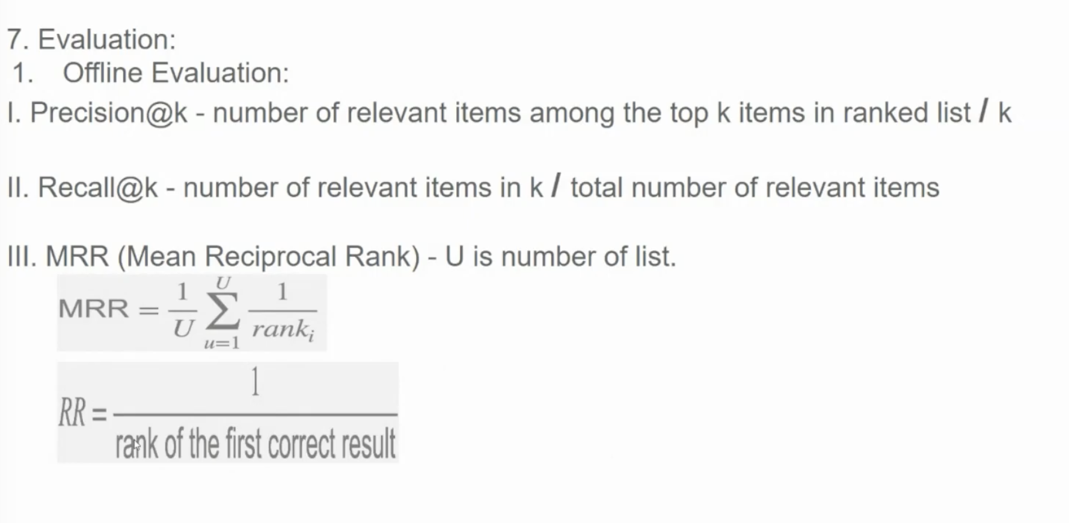

**Understanding Offline Evaluation Metrics for Recommendation Systems**

The provided image outlines several key offline metrics used to evaluate the performance of recommendation systems. Let's break down each metric:

**1. Precision@k and Recall@k**

* **Precision@k:** Measures the proportion of relevant items among the top k items in a ranked list.
  + **Formula:** Precision@k = Number of relevant items in top k / k
* **Recall@k:** Measures the proportion of relevant items that are retrieved among the top k items.
  + **Formula:** Recall@k = Number of relevant items in top k / Total number of relevant items

**Example:**

Consider a search engine that returns 10 results for a query. If 5 of the top 10 results are relevant, then:

* Precision@10 = 5/10 = 0.5
* Recall@10 depends on the total number of relevant items in the entire dataset. If there are 20 relevant items in total, and 5 of them are in the top 10, then Recall@10 = 5/20 = 0.25

**2. Mean Reciprocal Rank (MRR)**

* Measures the average reciprocal rank of the first relevant item in a ranked list.
* A higher MRR indicates that relevant items are ranked higher.

**Formula:**

MRR = (1/rank_1 + 1/rank_2 + ... + 1/rank_u) / U

Where:

* U is the number of user queries.
* rank_i is the rank of the first relevant item for the i-th query.

**Example:**

If for the first query, the relevant item is ranked 3rd, for the second query, it's ranked 1st, and for the third query, it's ranked 2nd, then:

* MRR = (1/3 + 1/1 + 1/2) / 3 = 11/18

**3. Reciprocal Rank (RR)**

* A simpler metric that measures the reciprocal rank of the first relevant item in a single ranked list.

**Formula:**

RR = 1 / rank

Where rank is the rank of the first relevant item.

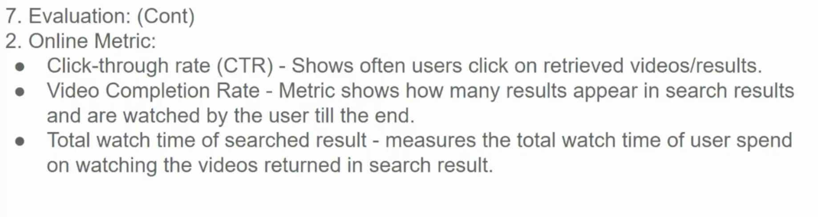

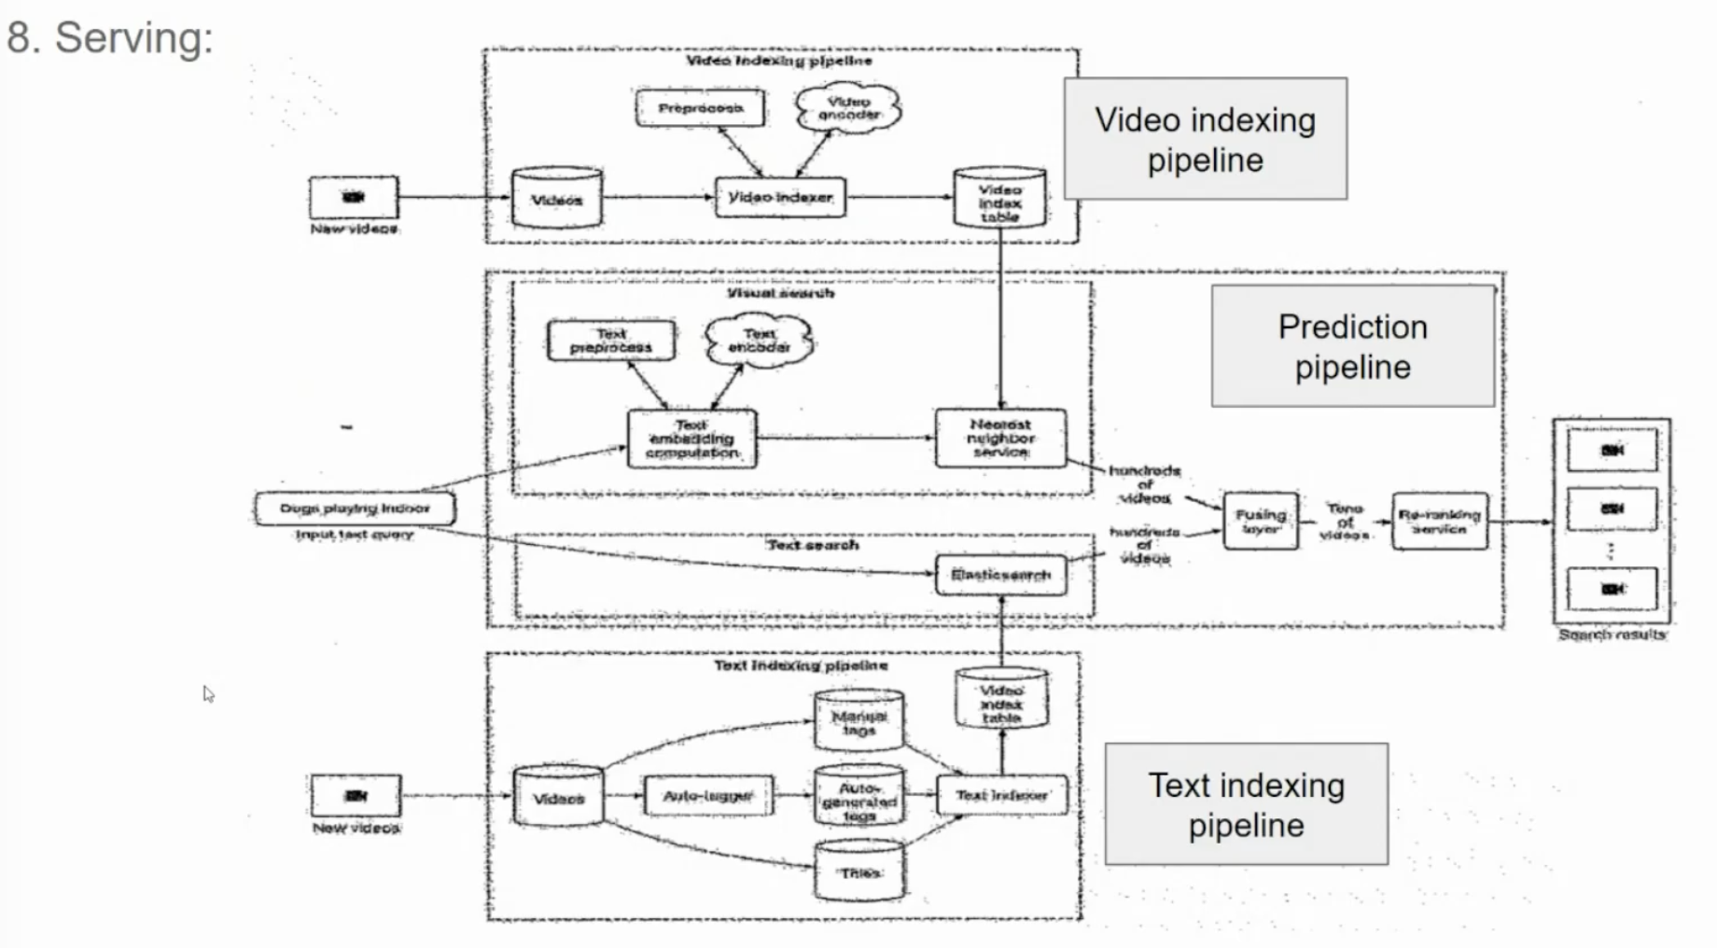

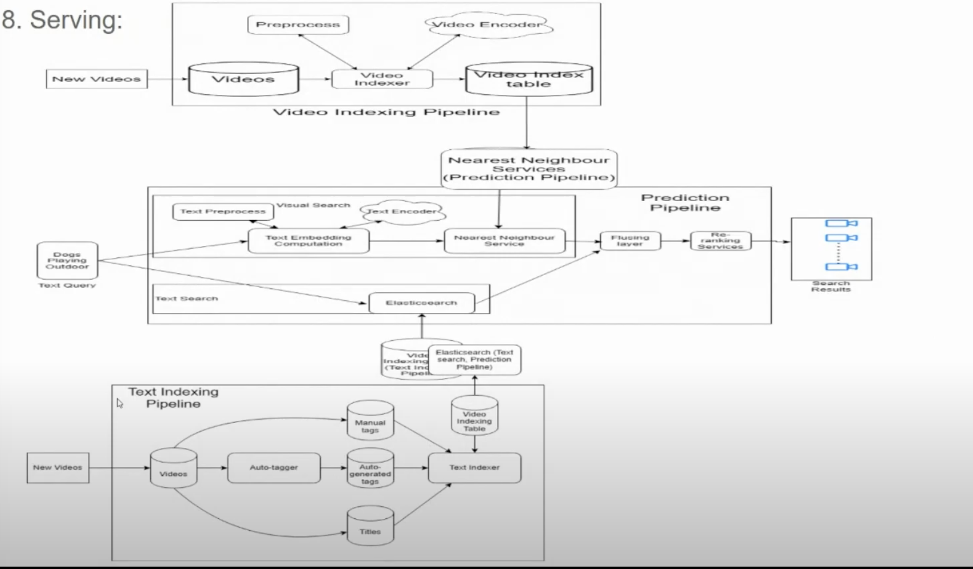

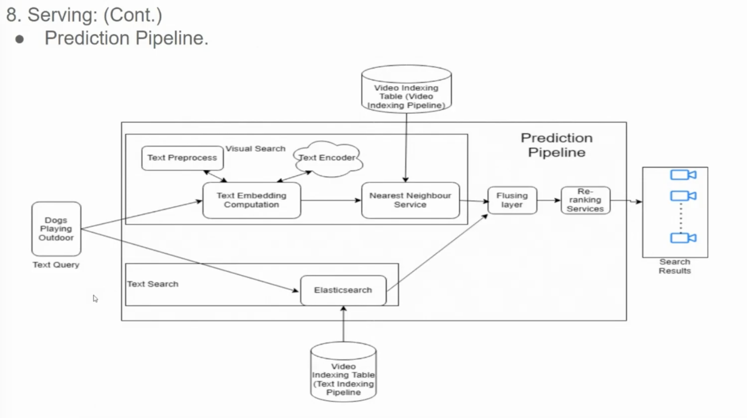

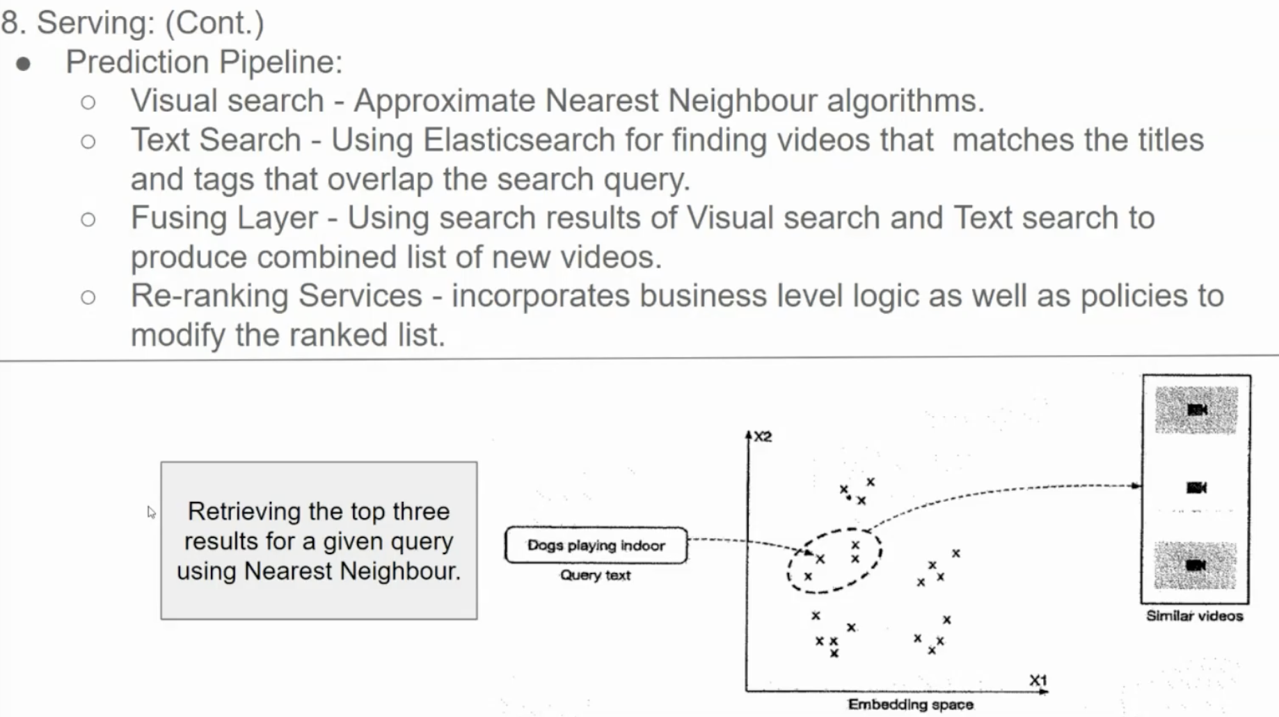

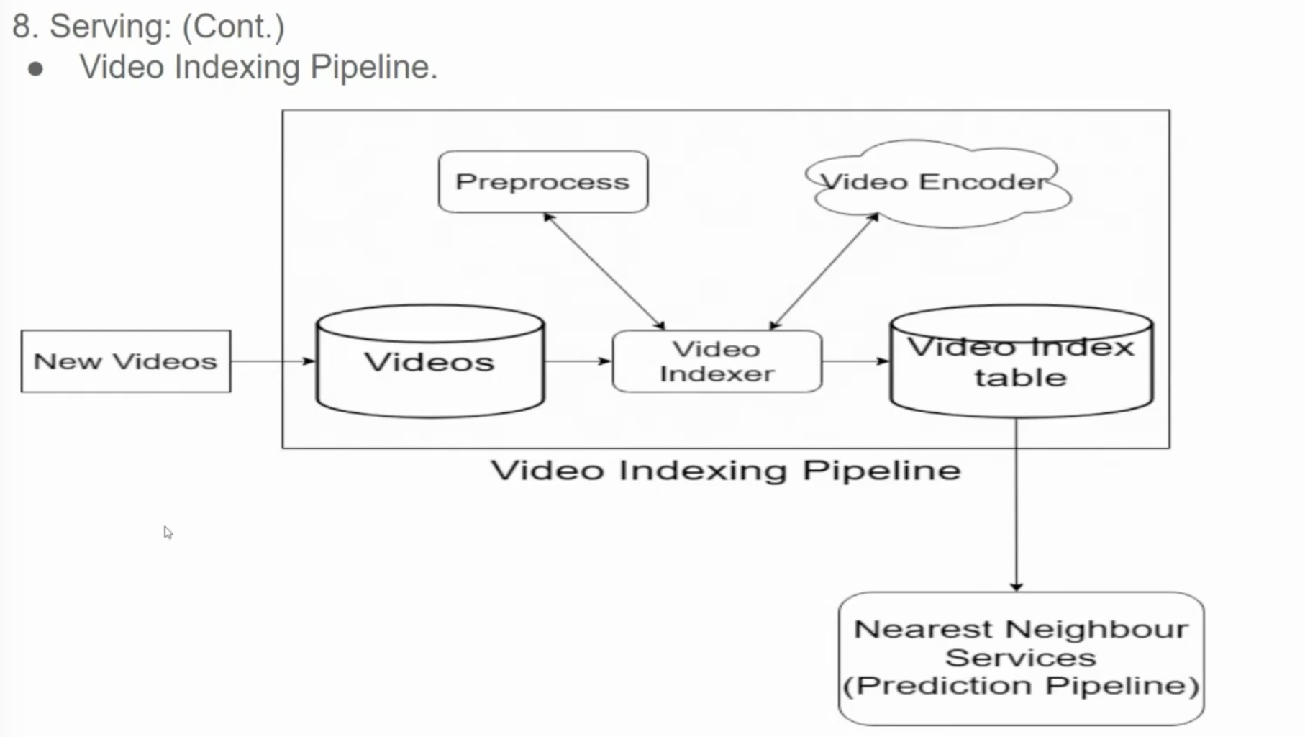

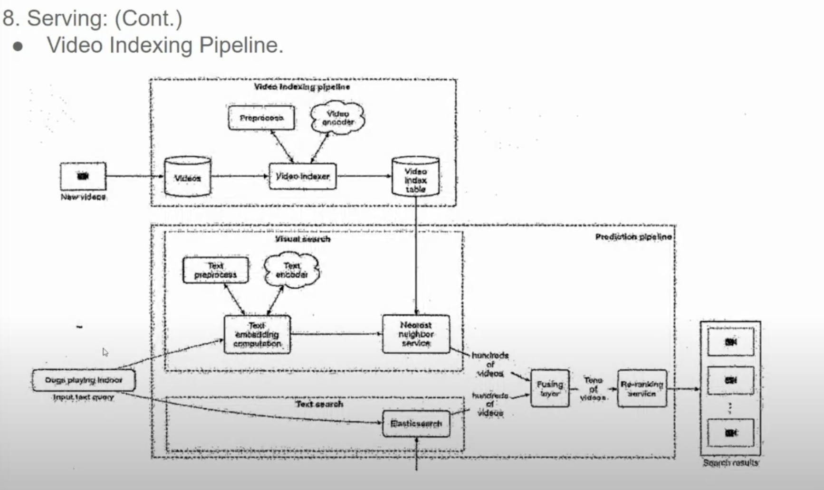

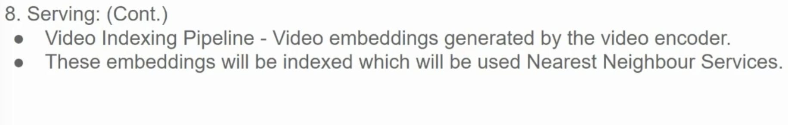

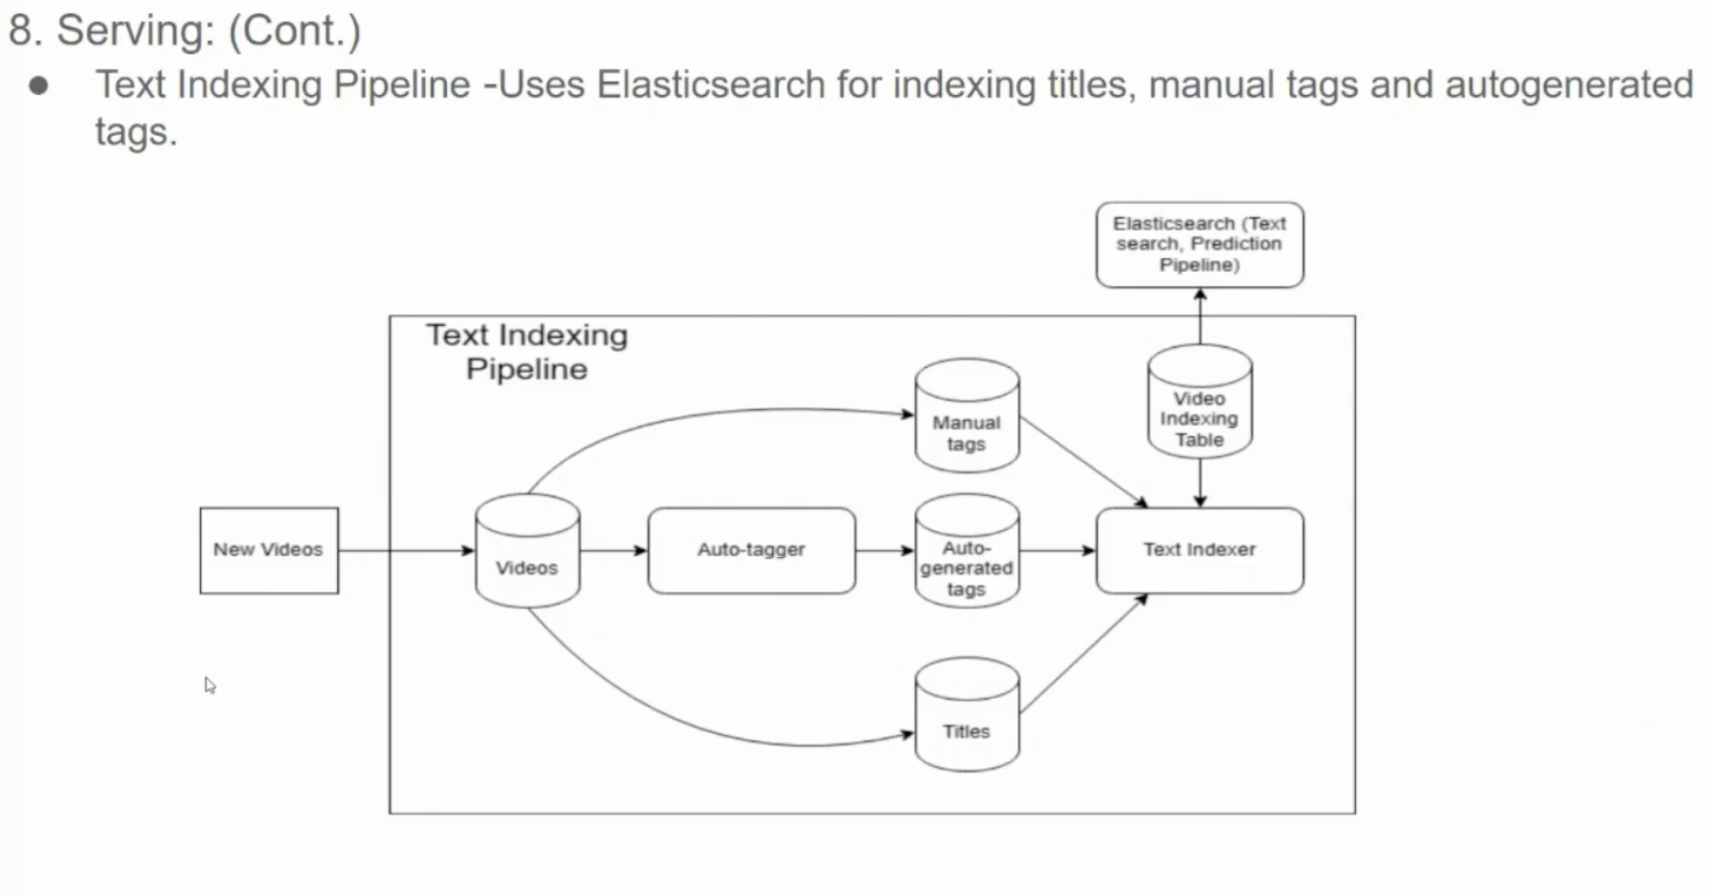

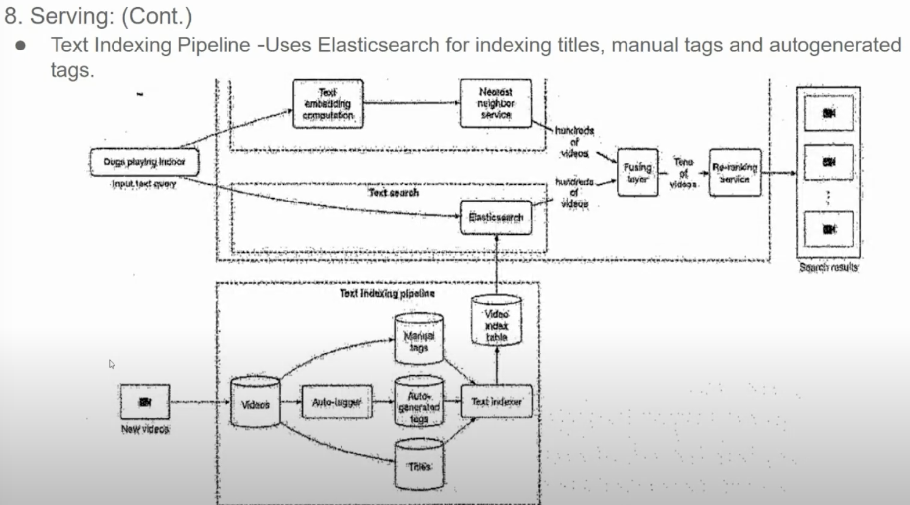

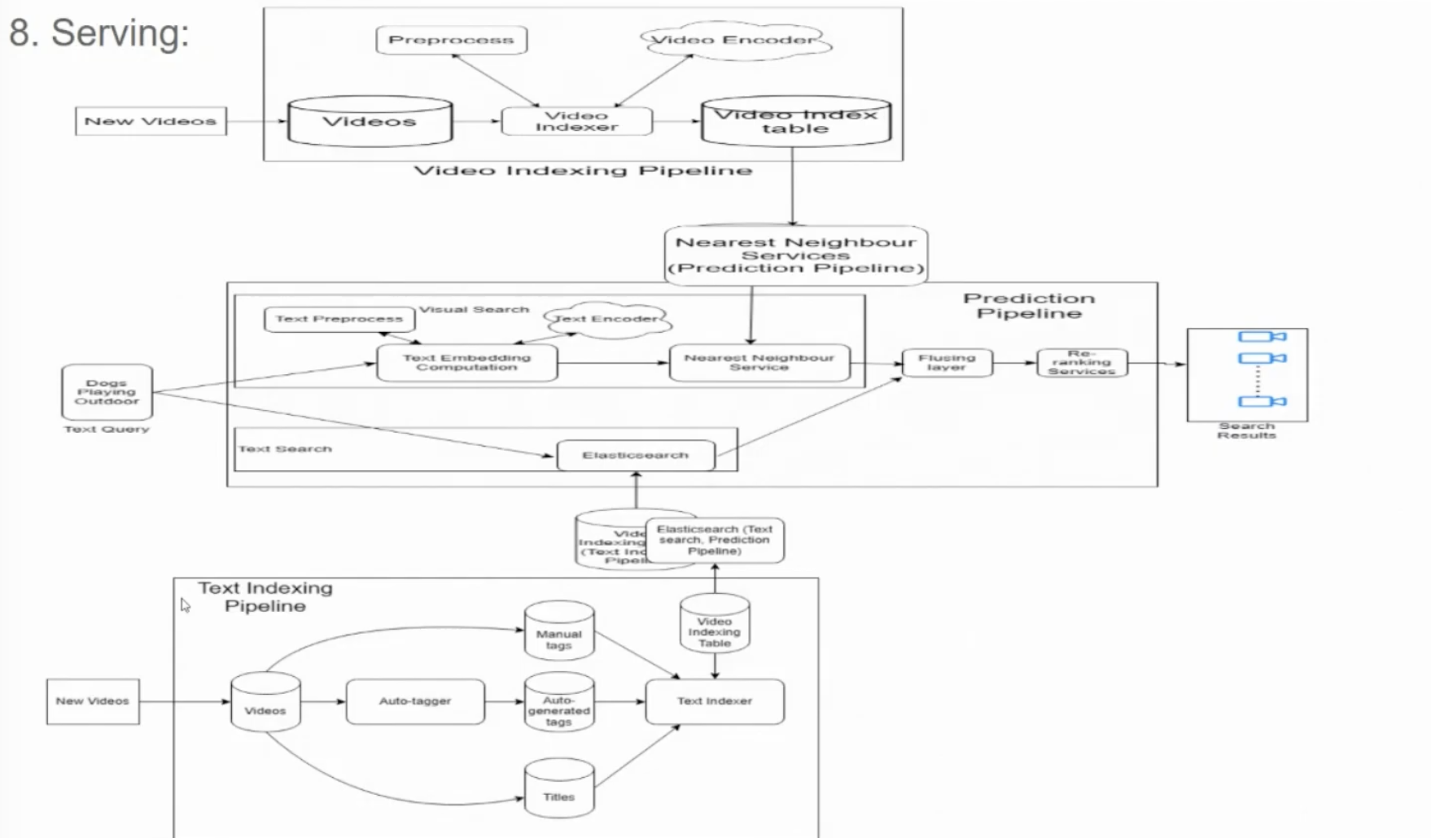

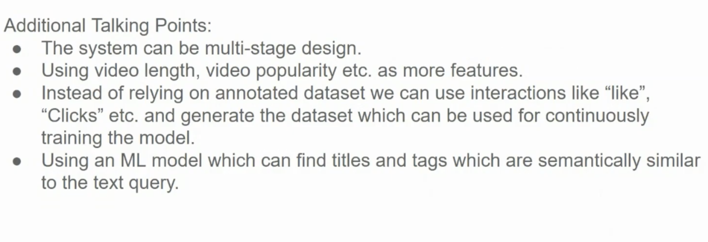

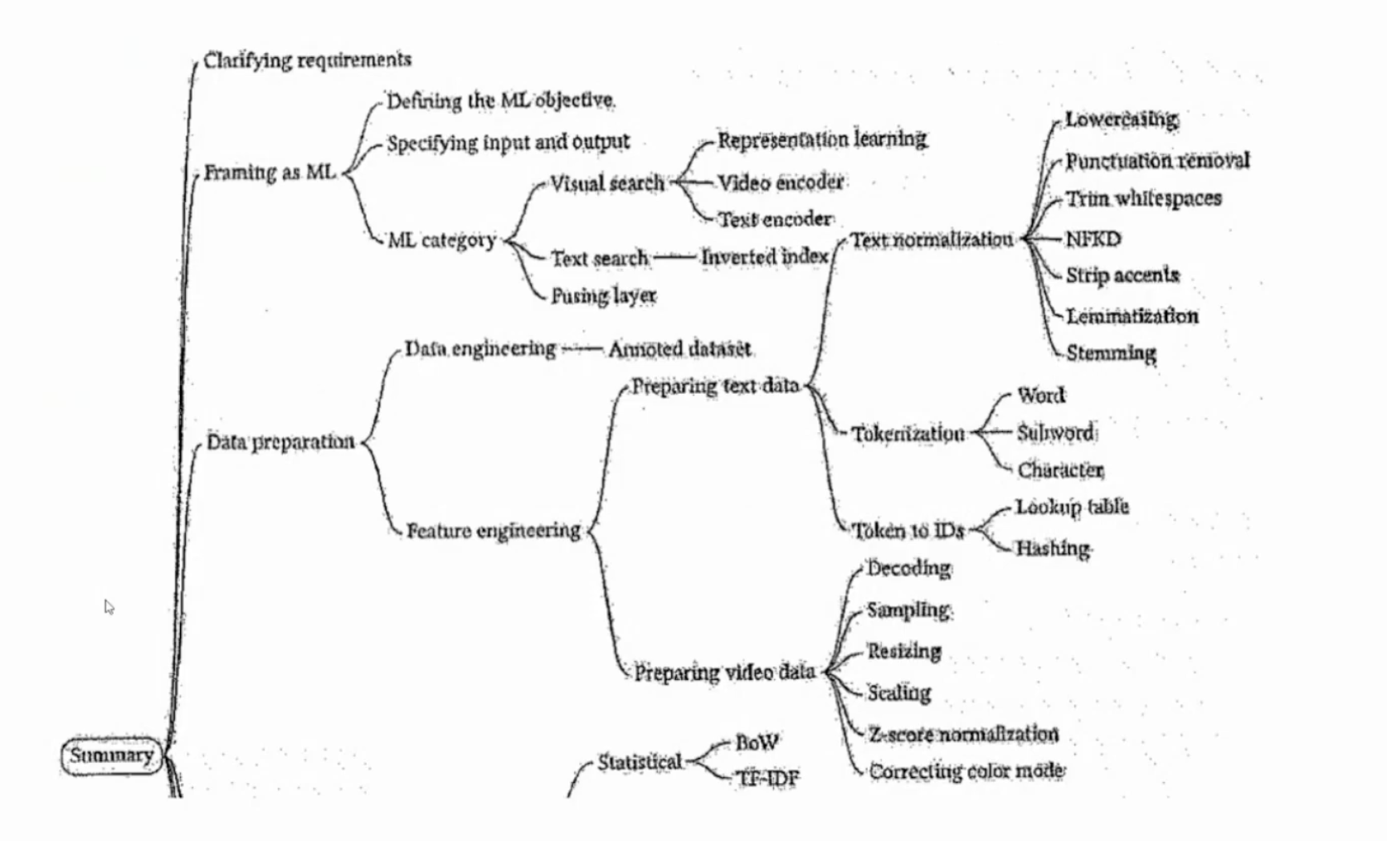

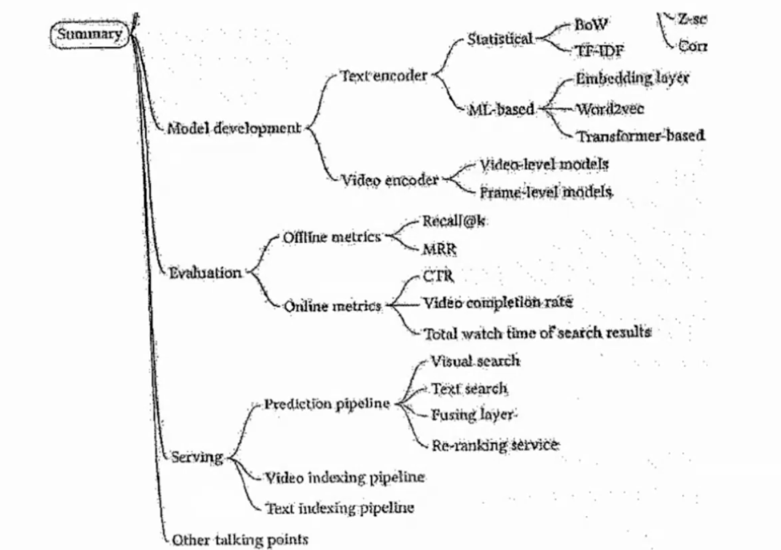  
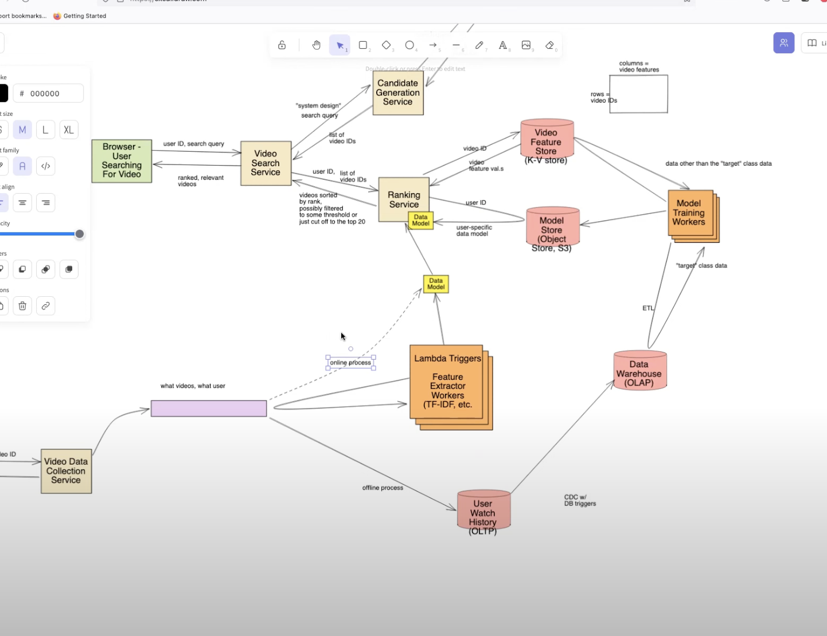

https://www.youtube.com/watch?v=nprPYgn4E58&list=PLlvnxKilk3aKx0oFua-HTtFf-d_inQ8Qn&index=3